JAVA PROGRAMMING
PROGRAM:1
TITLE:ARITHMETIC
A JAVA PROGRAM THAT TAKES TWO INTEGERS AS INPUT FROM THE USER AND CALCULATES THEIR SUM,DIFFERENCE,PRODUCT,AND QUOTIENT USING ARITHMETIC OPERATORS
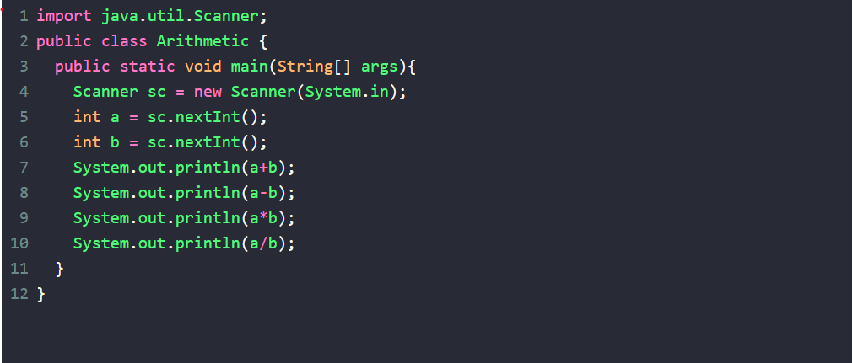
INPUT:
56
89
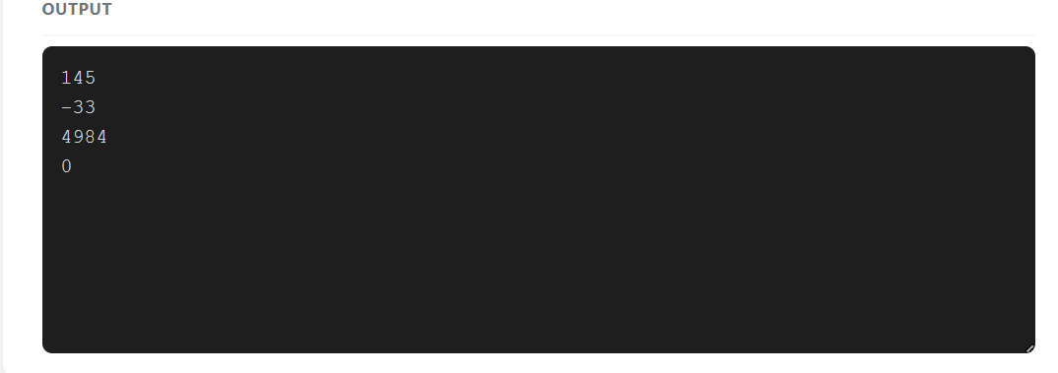

PROGRAM:2
TITLE:MAX
A JAVA PROGRAM TO FIND THE MAXIMUM OF THREE NUMBERS USING CONDITIONAL STATEMENTS
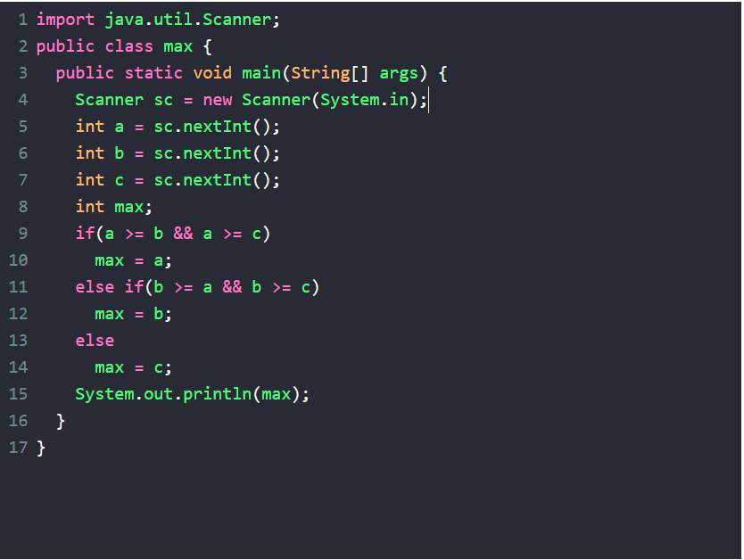
INPUT:
5 6 7

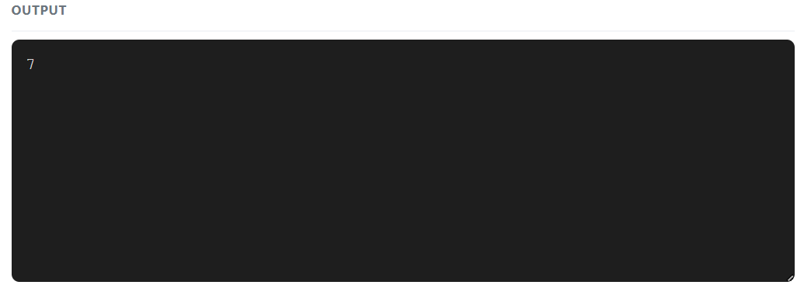

PROGRAM:3
TITLE:LEAP
A JAVA PROGRAM TO CHECK WHETHER A GIVEN YEAR IS A LEAP YEAR OR NOT USING CONDITIONAL STATEMENTS
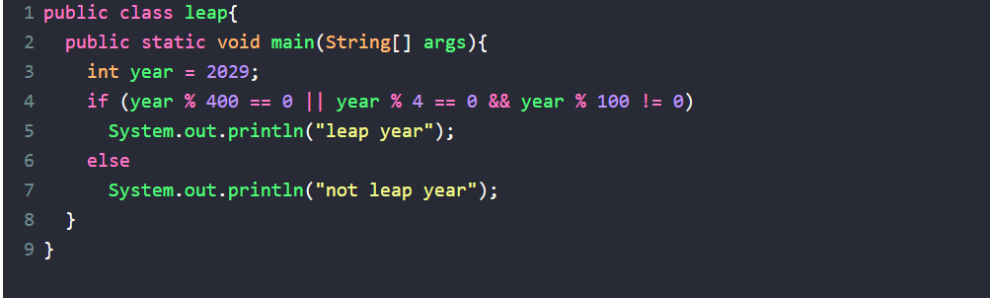
INPUT:
2024
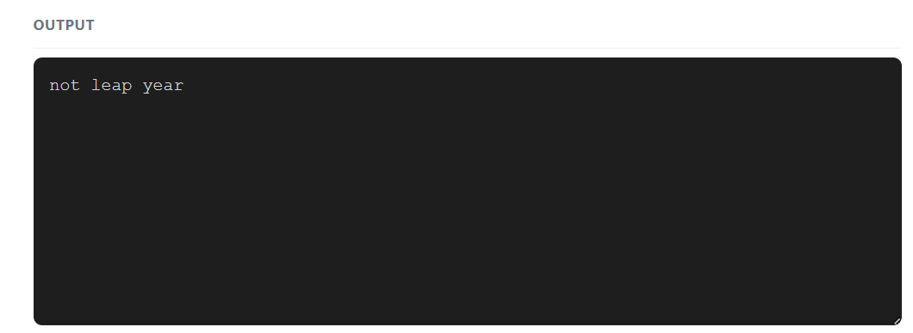

PROGRAM:4
TITLE:FIBONACCI
A JAVA PROGRAM TO PRINT THE FIBONACCI SERIES UP TO A GIVEN NUMBER USING LOOPS
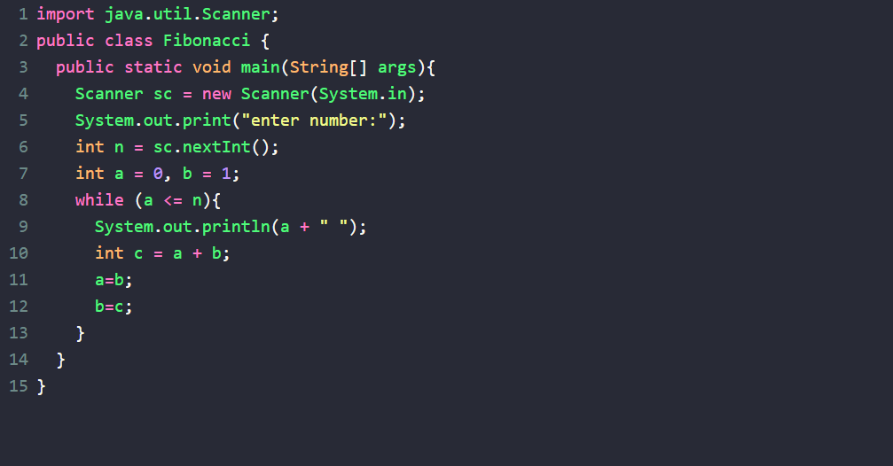
INPUT:
5
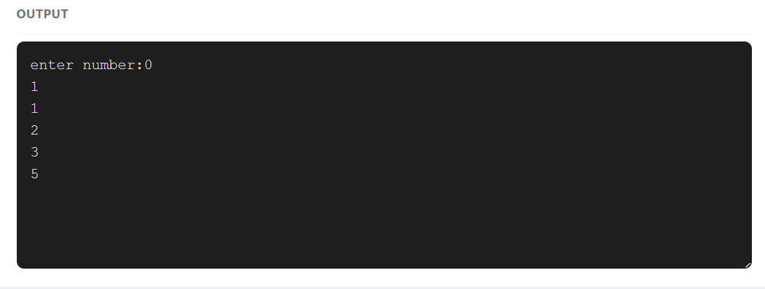

PROGRAM:5
TITLE:FACTORIAL
A JAVA PROGRAM TO CALCULATE THE FACTORIAL OF A GIVEN NUMBER USING LOOPS
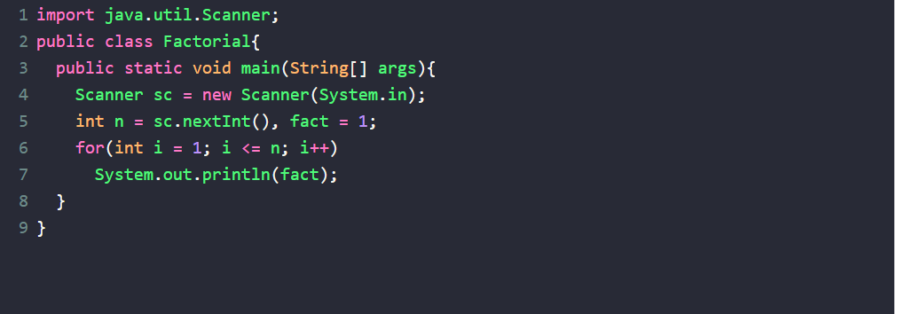
INPUT:
5
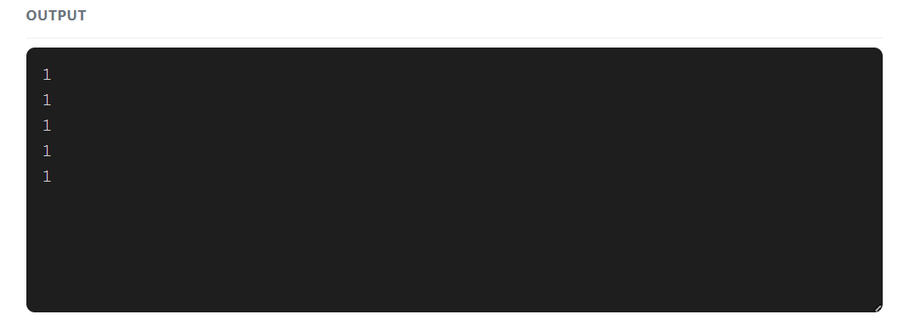

PROGRAM:6
TITLE:RT-PATTERN
A JAVA PROGRAM TO PRINT THE FOLLOWING PATTERN USING LOOPS:
*
**
***
****
*****
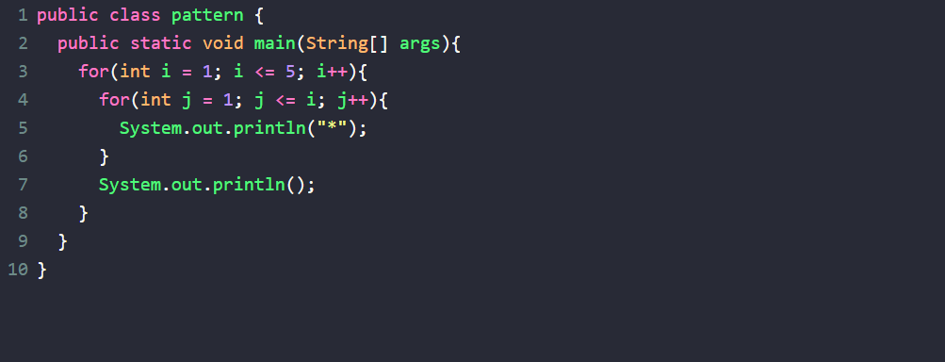
INPUT:
5
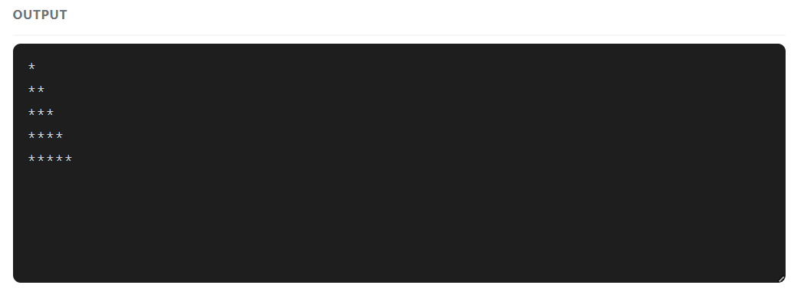

PROGRAM:7
TITLE:SEARCH
A JAVA PROGRAM TO IMPLEMENT BINARY SEARCH ON AN ARRAY OF INTEGERS USING LOOPS AND CONDITIONAL STATEMENTS
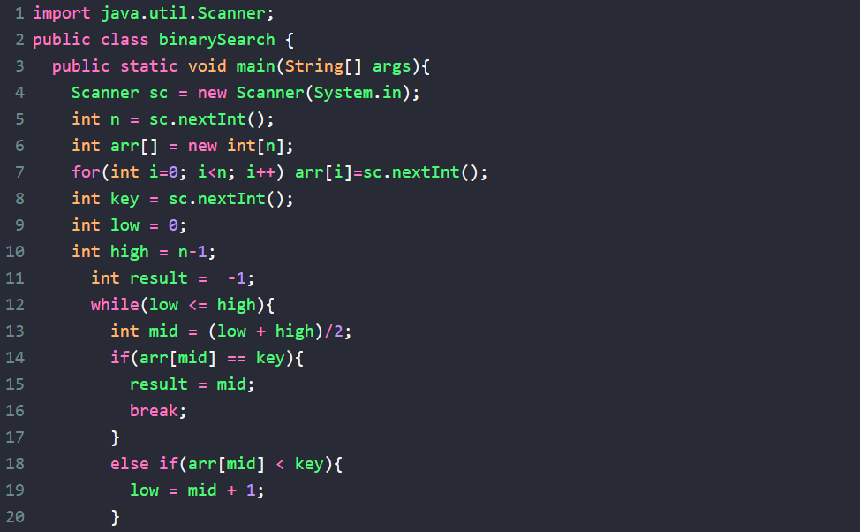
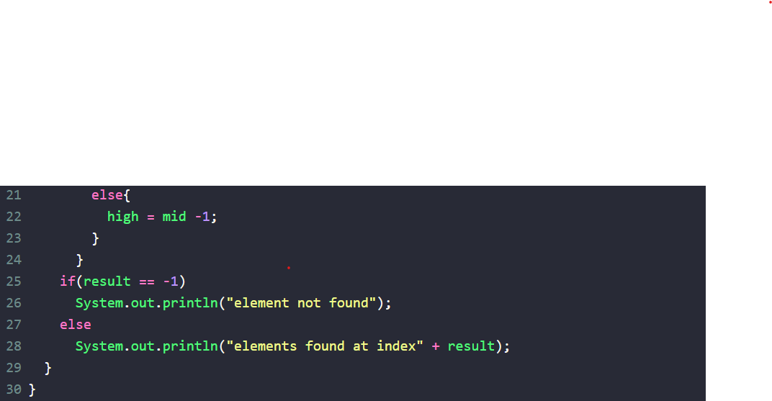

INPUT:
5
1 2 3 4 5
5
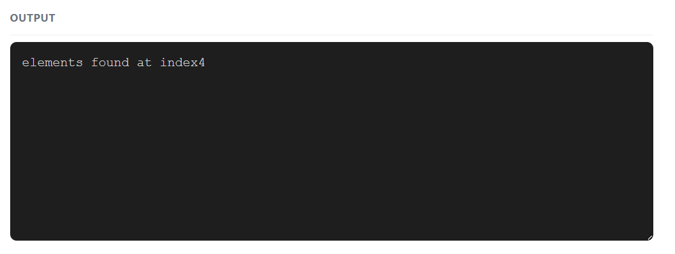
PROGRAM:8
TITLE:GCD
A JAVA PROGRAM TO FIND THE PROGRAM TO FIND THE GCD (GREATEST COMMON DIVISION)OF TWO NUMBERS USING LOOPS AND CONDITIONAL STATEMENTS
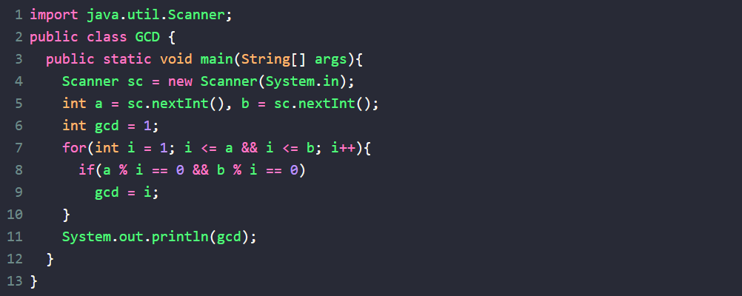
INPUT:
12 18
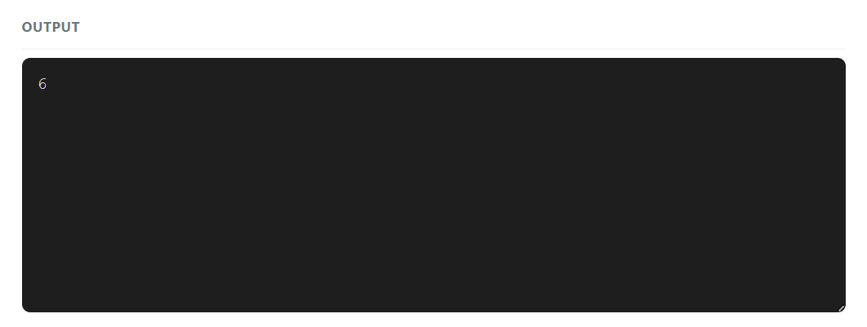

PROGRAM:9
TITLE:PRIME
A JAVA PROGRAM TO CHECK WHETHER A GIVEN NUMBER IS PRIME NUMBER OR NOT USING OOPS AND CONDITIONAL STATEMENTS
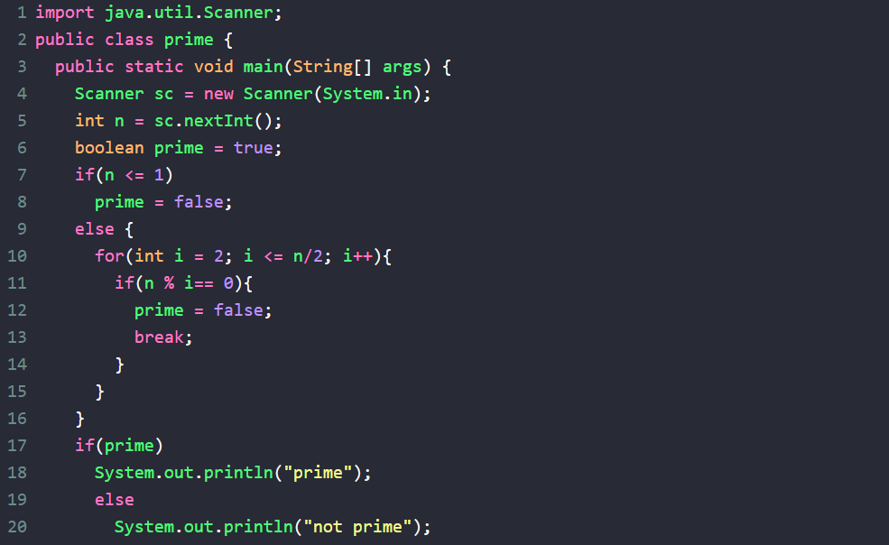
INPUT:
17
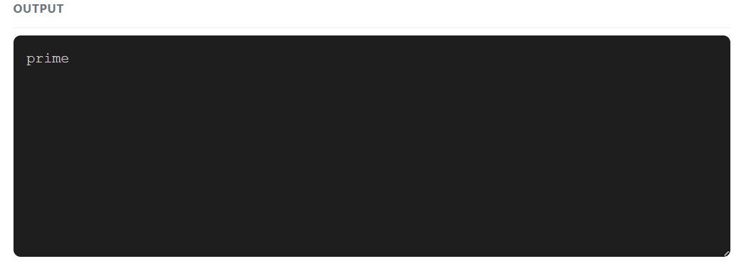

PROGRAM:10
TITLE:SORT
A JAVA PROGRAM TO IMPLEMENTS SELECTION SORT ON AN ARRAY OF INTEGERS USING LOOPS AND CONDITIONAL STATEMENTS
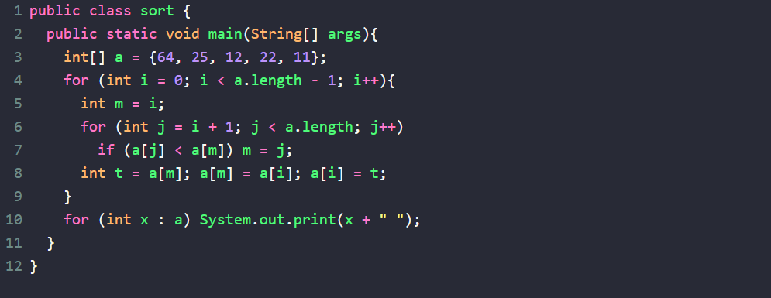
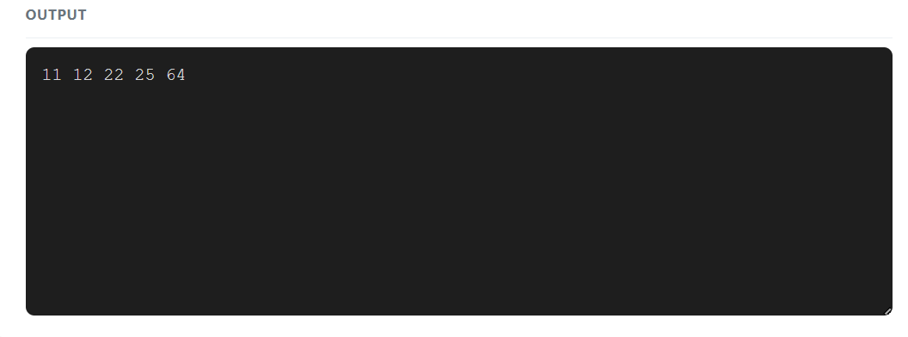

PROGRAM:11
TITLE:TABLE
A JAVA PROGRAM TO PRINT THE MULTIPLICATION TABLE OF GIVEN NUMBER USING LOOP
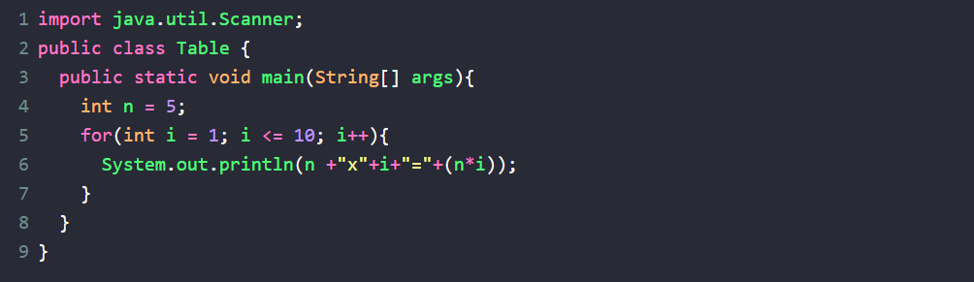
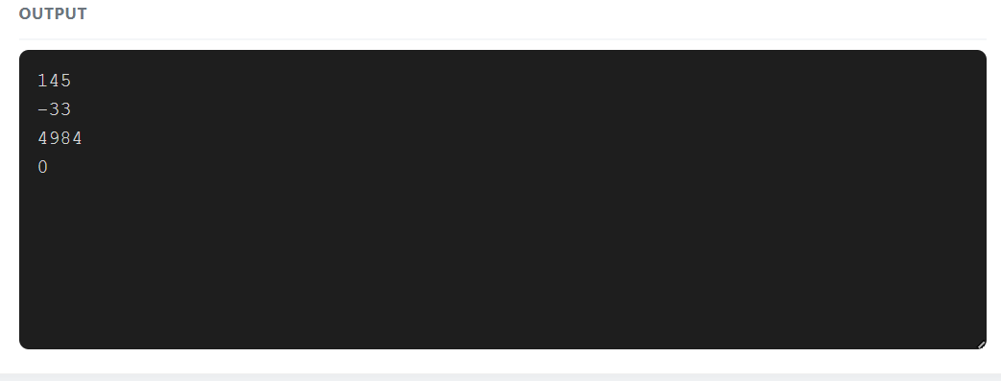
PROGRAM:12
TITLE:FACTORIAL
A JAVA PROGRAM TO FIND THE FACTORIAL OF A GIVEN NUMBER USING RECURSION
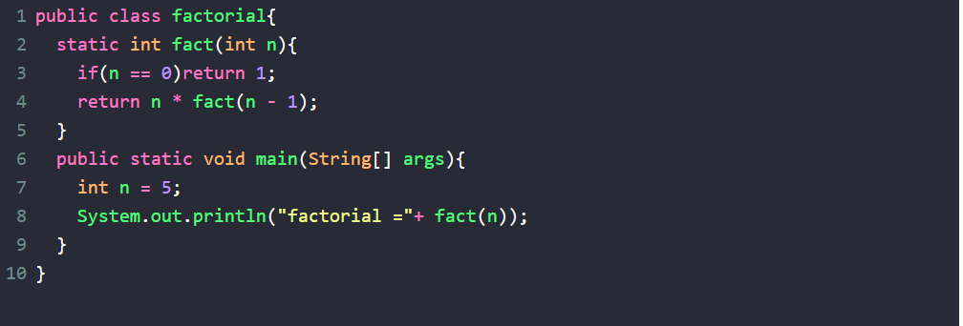
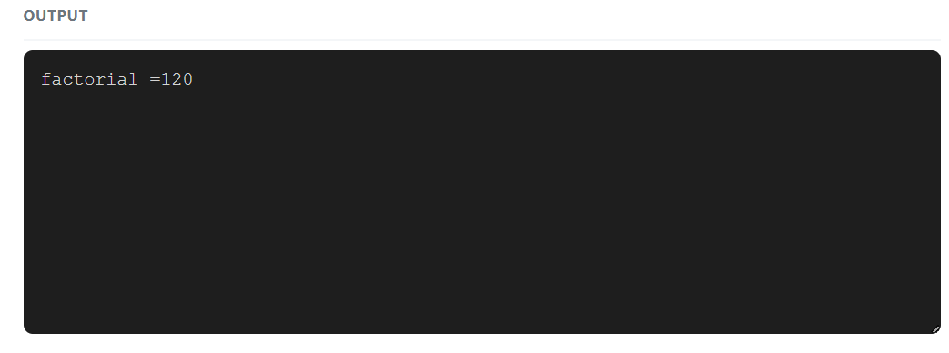
PROGRAM:13
TITLE:LT-PATTERN
A JAVA PROGRAM TO PRINT THE FOLLOWING PATTERN USING LOOPS
*****
****
***
**
*
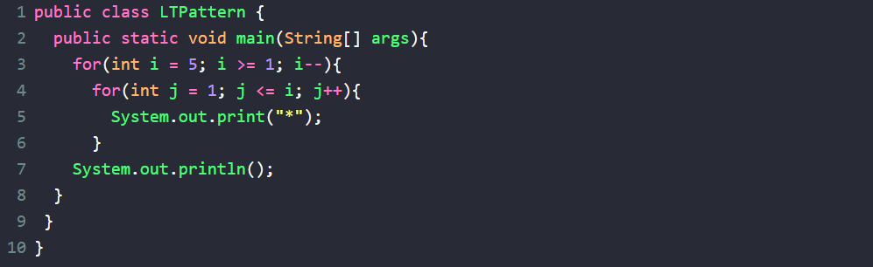
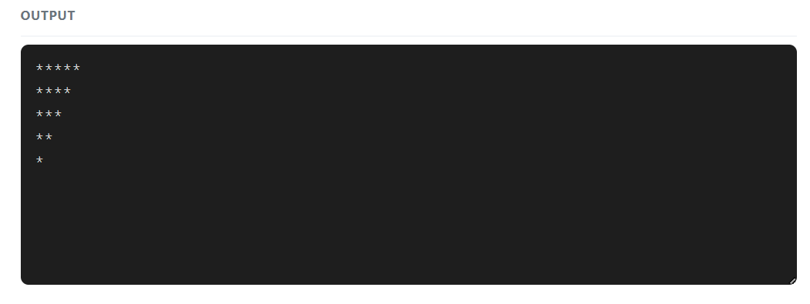
PROGRAM:14
TITLE:LCM
A JAVA PROGRAM TO FIND THE LCM(LEAST COMMON MULTIPLE)OF TWO NUMBERS USING LOOPS AND CONDITIONAL STSTEMENTS
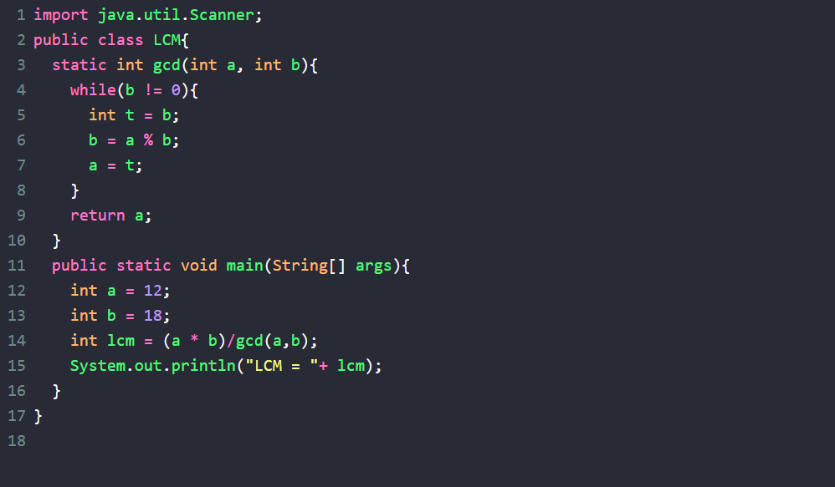
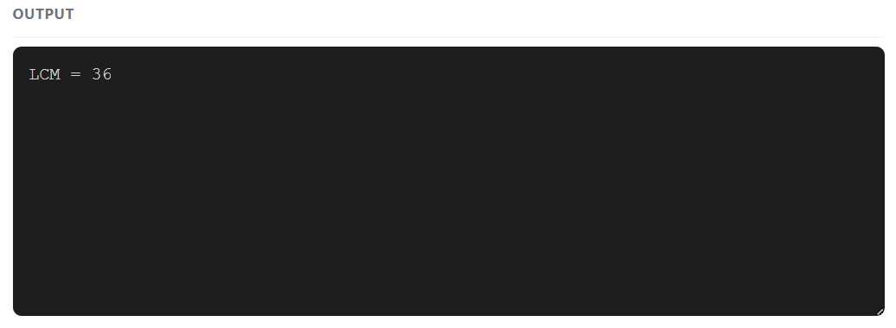
PROGRAM:15
TITLE:D TO B
A JAVA PROGRAM TO CONVERT A DECIMAL NUMBER TO BINARY USING LOOPS AND CONDITIONAL STATEMENTS

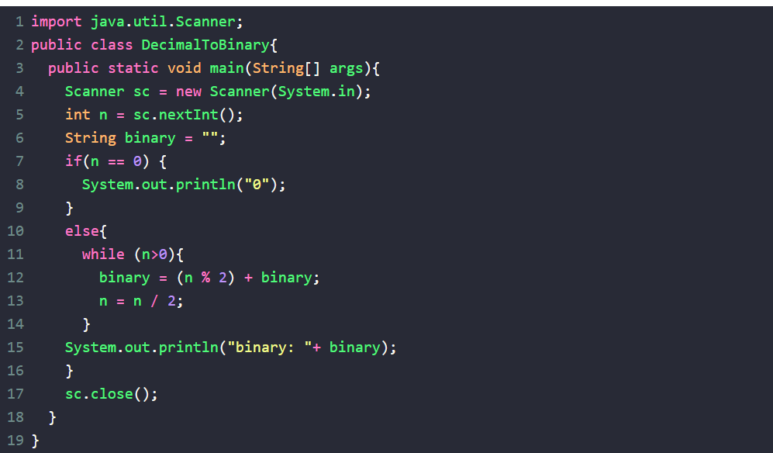
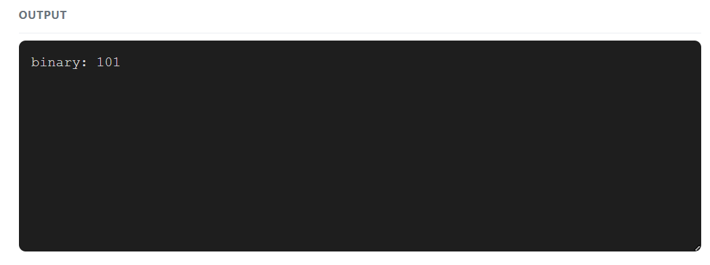
PROGRAM:16
TITLE:B TO D
A JAVA PROGRAM TO CONVERT A BINARY NUMBER TO DECIMAL USING LOOPS AND CONDITIONAL STATEMENTS
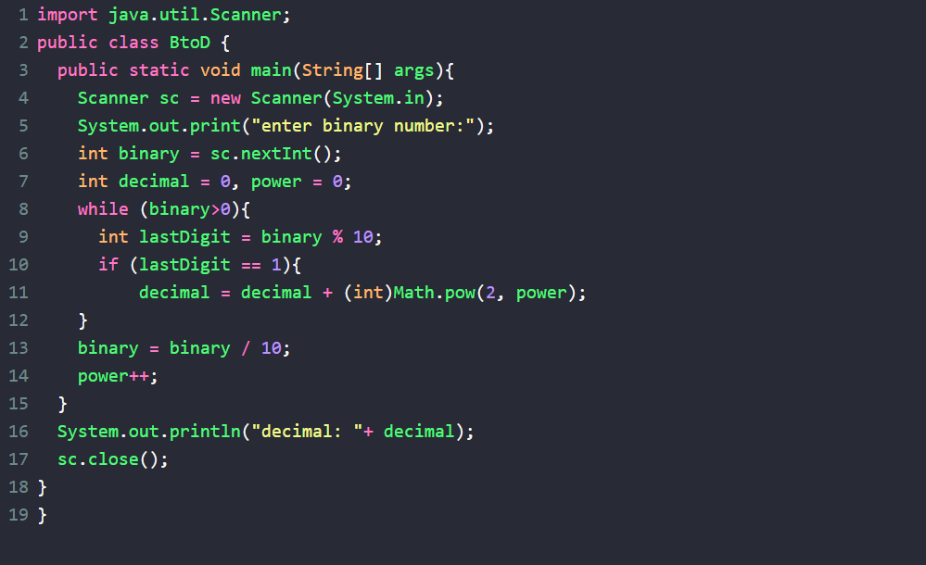
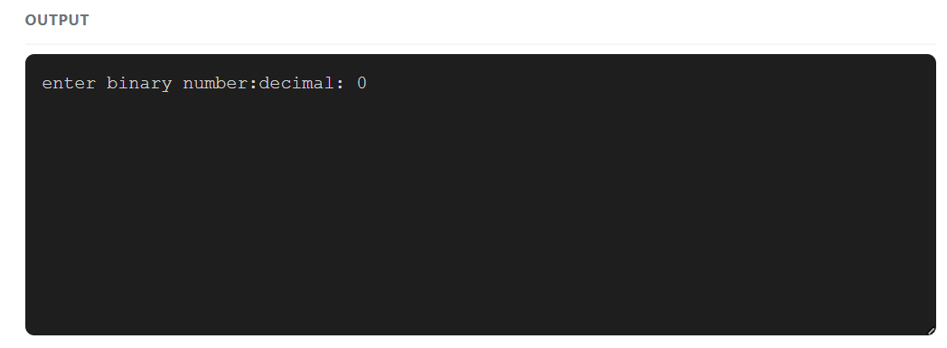
PROGRAM:17
TITLE:SUM
A JAVAPROGRAM TO CALCULATE THE SUM OF THE DIGITS OF GIVEN NYMBER USING LOOPS AND CONDITIONAL STATEMENTS
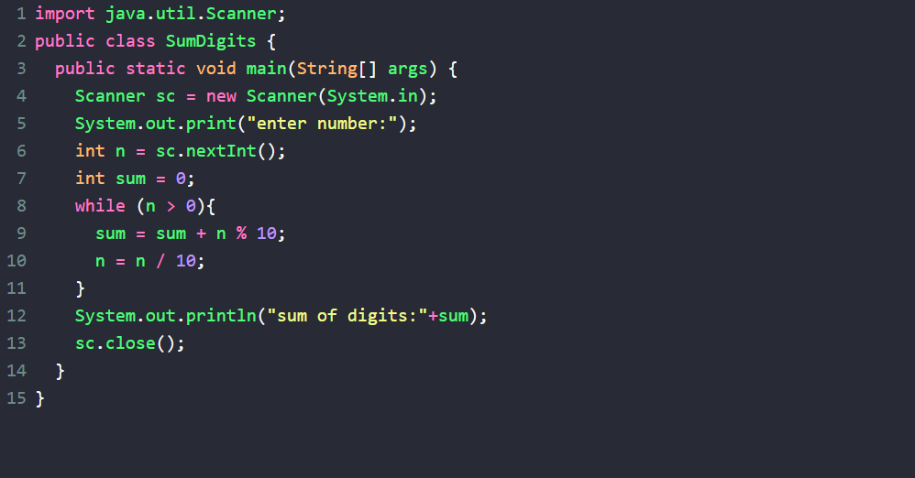
INPUT:
1 2 3
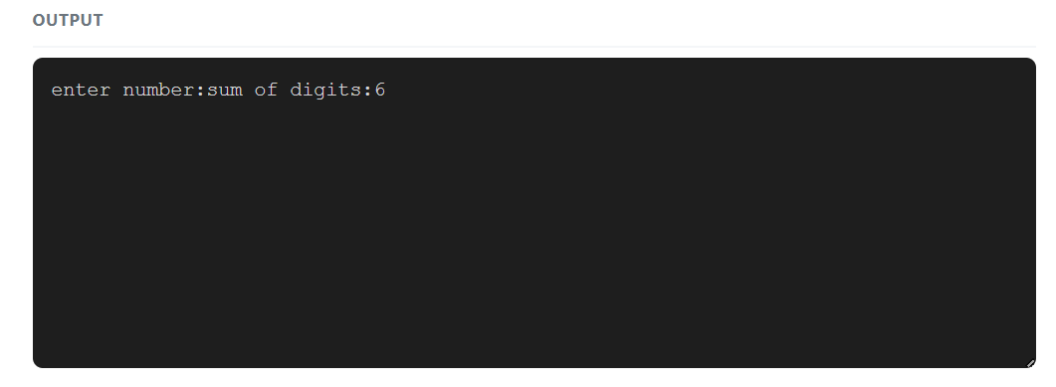
PROGRAM:18
TITLE:PRODUCT
A JAVA PROGRAM TO CALCULATE THE PRODUCT OF THE DIGITS OF A GIVEN NUMBERS USING LOOPS AND CONDITIONAL STATEMENTS
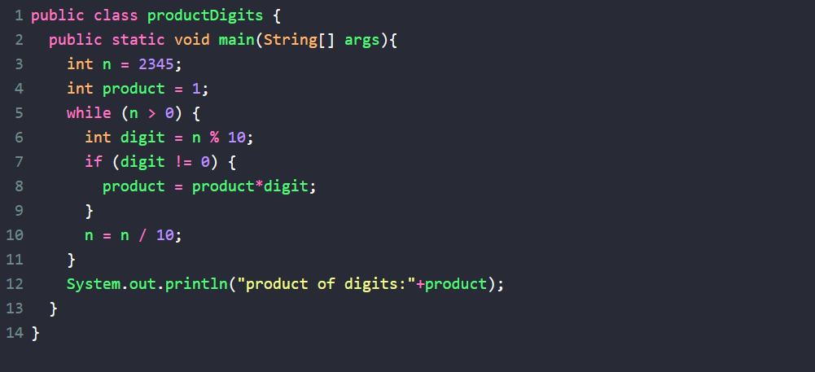
INPUT:
40
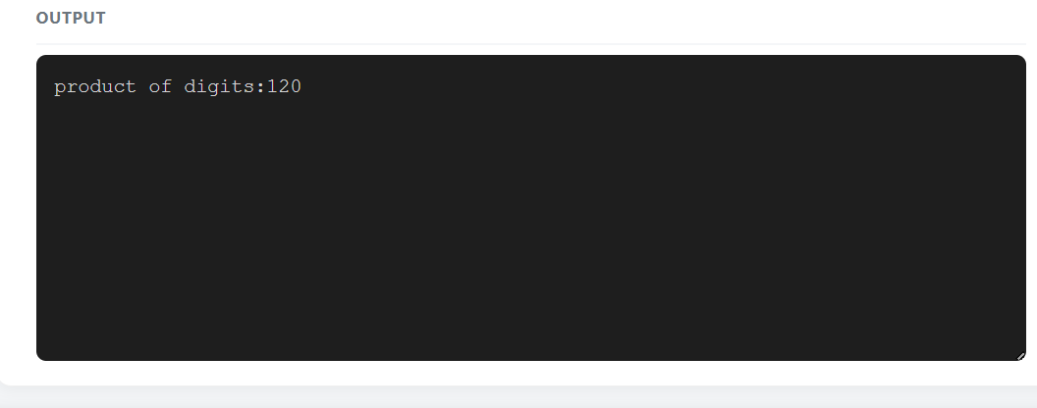
PROGRAM:19
TITLE:POWER
A JAVA PROGRAM TO FIND THE PROGRAM OF A NUMBERS USING LOOPS AND CONDITIONAL STATEMENTS
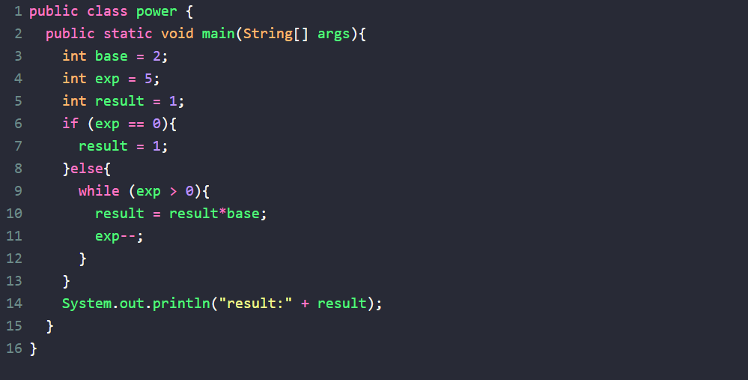
INPUT:
4
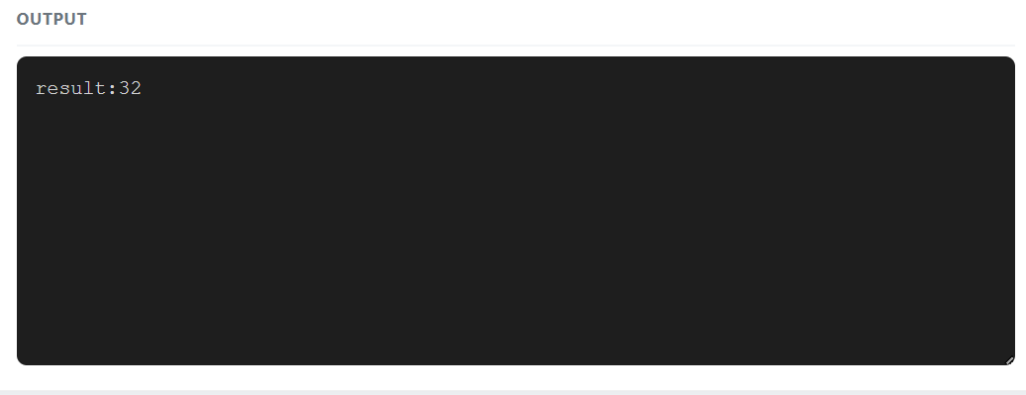
PROGRAM:20
TITLE:AREA CIRCLE
A JAVA PROGRAM TO CALCULATE THE AREA OF A CIRCLE USING THE RADIUS INPUT BY THE USER
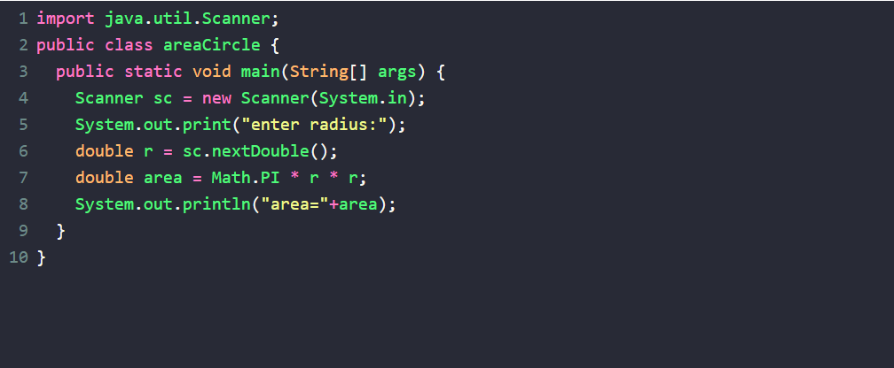
INPUT:
25
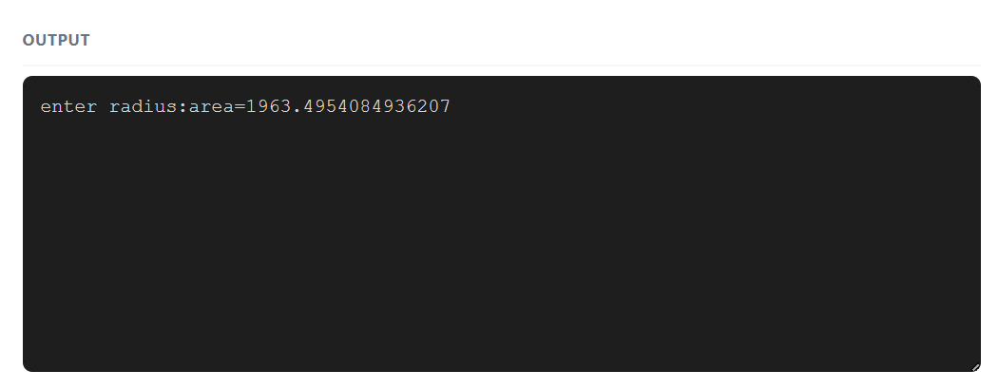
PROGRAM:21
TITLE:SHPERE
A JAVA PROGRAM TO CALCULATE THE VOLUME OF A SPHERE USING THE RADIUS INPUT BY THE USER
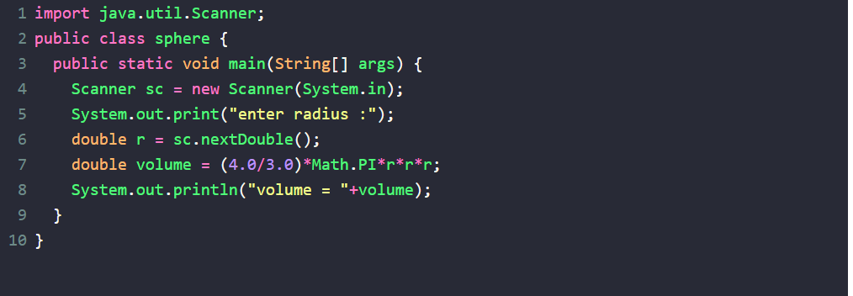
INPUT:
12
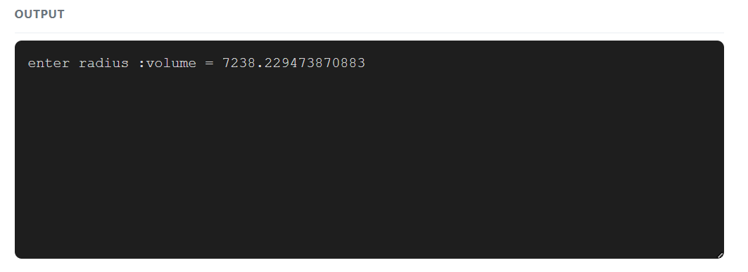
PROGRAM:22
TITLE:PALINDROME
A JAVA PROGRAM TO CHECK WHETHER A GIVEN STRING IS A PALINDROME OR NOT USING LOOPS AND CONDITIONAL STATEMENTS
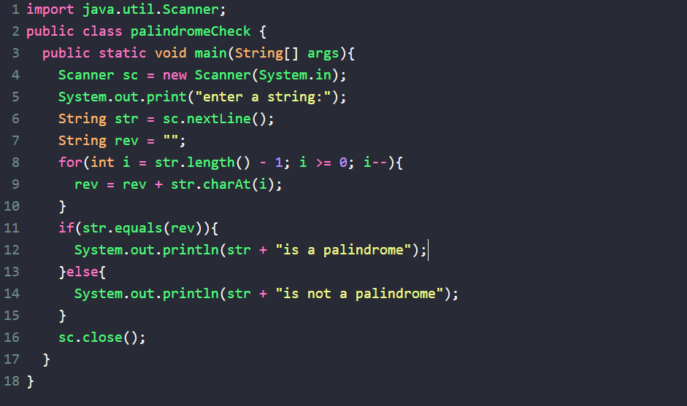
INPUT:
racecar
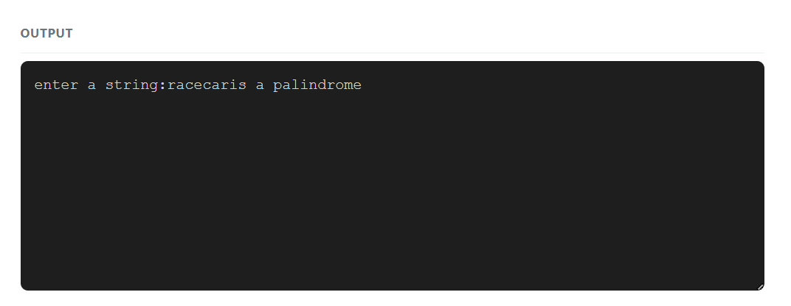
PROGRAM:23
TITLE:ARMSTRONG
A JAVA PROGRAM TO CHECK WHETHER A GIVEN NUMBER IS AN ARMSTRONG NUMBER OR NOT USING LOOPS AND CONDITIONAL STATEMENTS
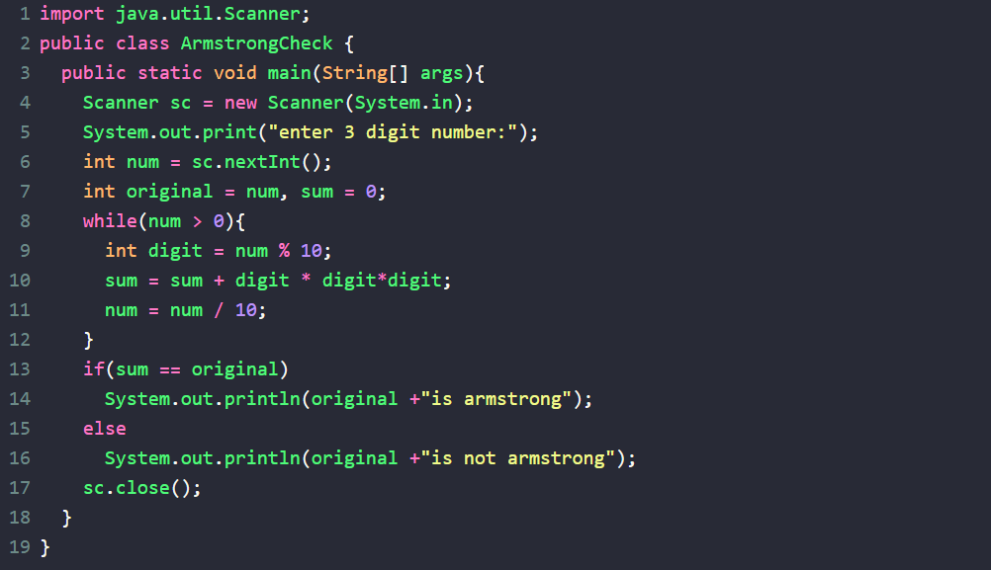
INPUT:
153
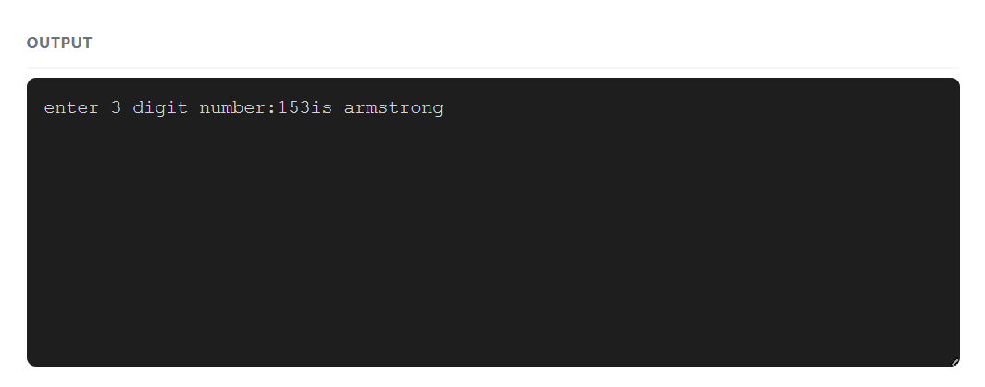
PROGRAM:24
TITLE:RT-NUM.PATTERN
A JAVA PROGRAM TO PRINT THE FOLLOWING PATTERN USING LOOPS
1
22
333
4444
55555
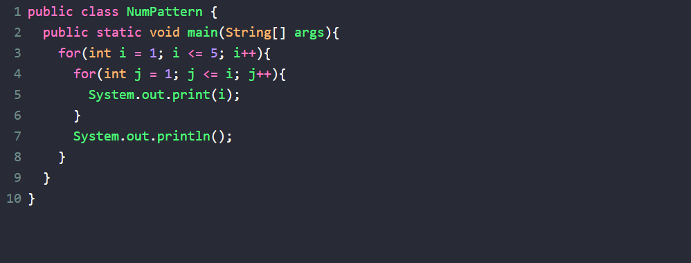
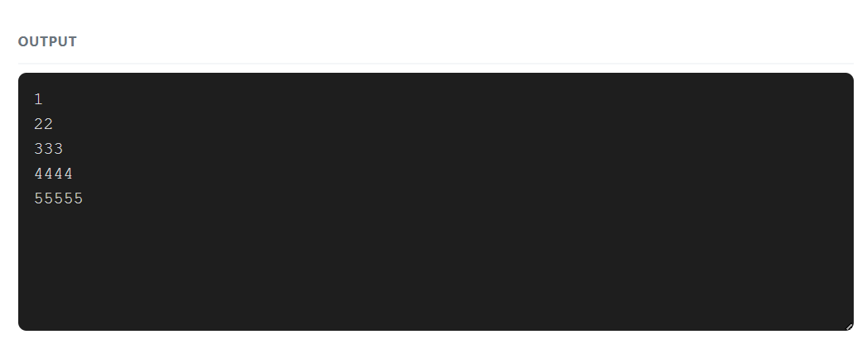
PROGRAM:25
TITLE:PERFECT
A JAVA PROGRAM TO CHECK WHETHER A GIVEN NUMBER IS A PERFECT NUMBER OR NOT USING LOOPS AND CONDITIONAL STATEMENTS
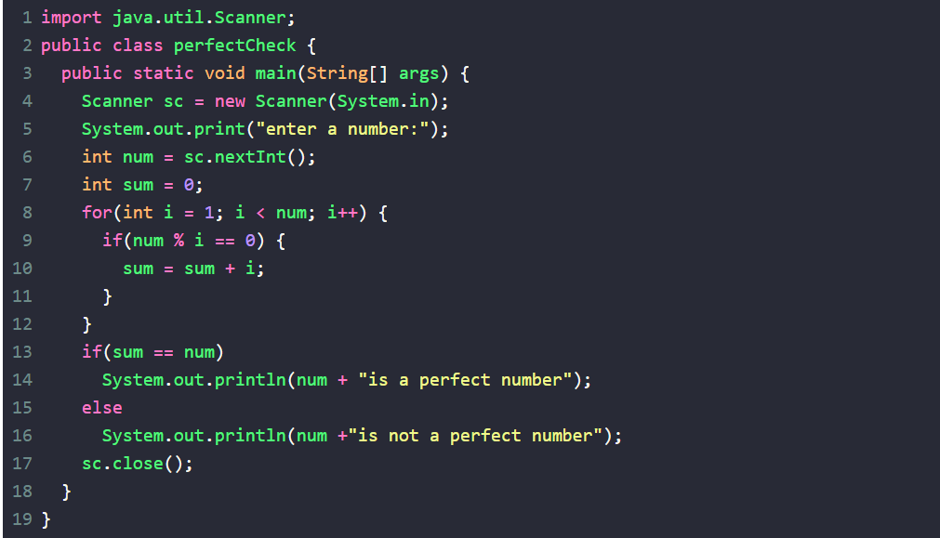
INPUT:
6
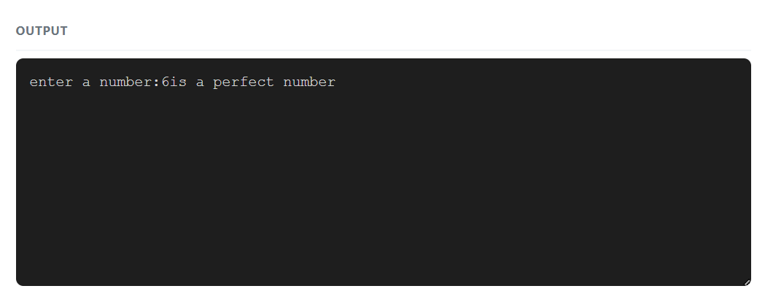
PROGRAM:26
TITLE:MAX ARRAY
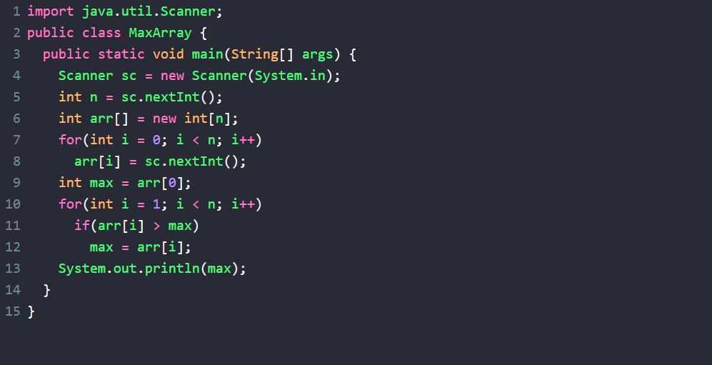
INPUT:
5
10 45 3 78 22
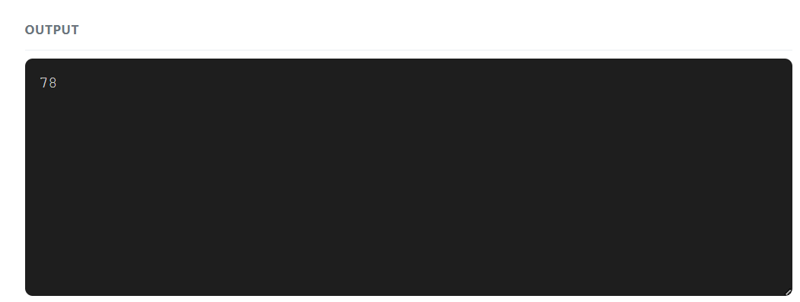
PROGRAM:27
TITLE:2ND MAX
A JAVA PROGRAM TO FIND THE SECOND LARGEST ELEMENT IN AN ARRAY OF INTEGERS USING LOOPS AND CONDITIONAL STATEMENTS
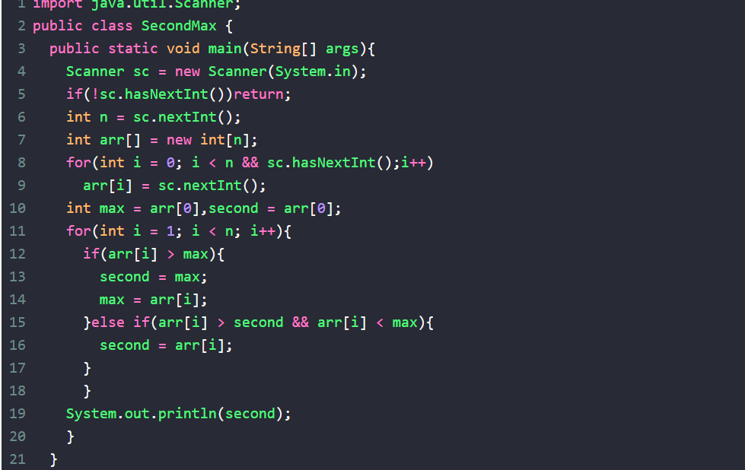
INPUT:
5 10 78
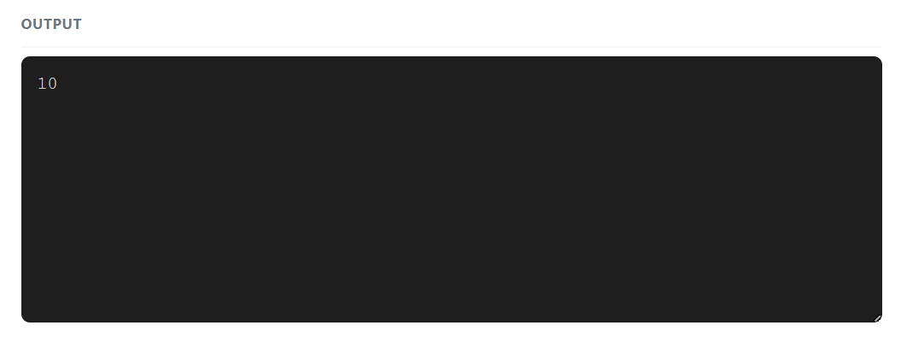
PROGRAM:28
TITLE:MIN
A JAVA PROGRAM TO FIND THE SMALLEST ELEMENT IN ARRAY OF INTEGERS USING LOOPS AND CONDITIONAL STATEMENTS
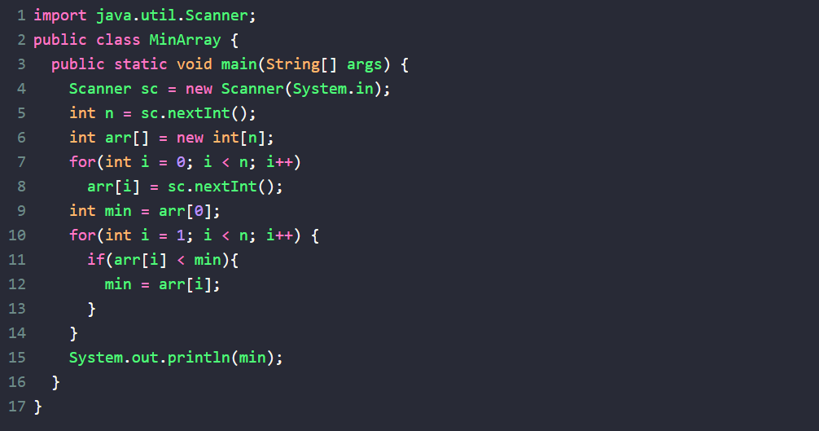
INPUT:
5
10 3 45 1 22
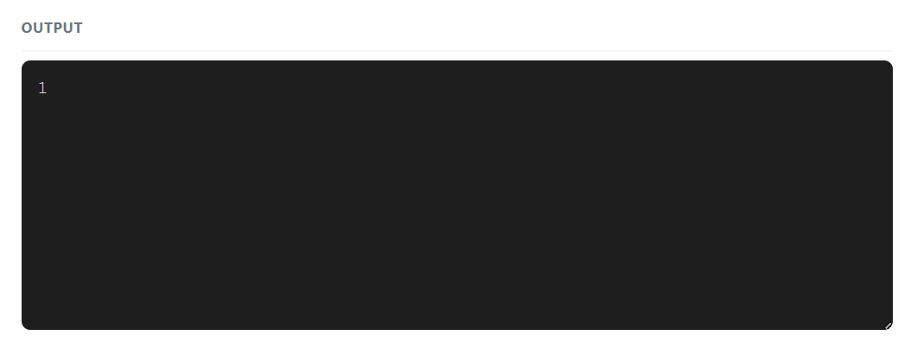
PROGRAM:29
TITLE:2ND MIN
A JAVA PROGRAM TO FIND THE SECOND SMALLEST ELEMENT IN ARRAY OF INTEGERS USING LOOPS AND CONDITIONAL STATEMENTS
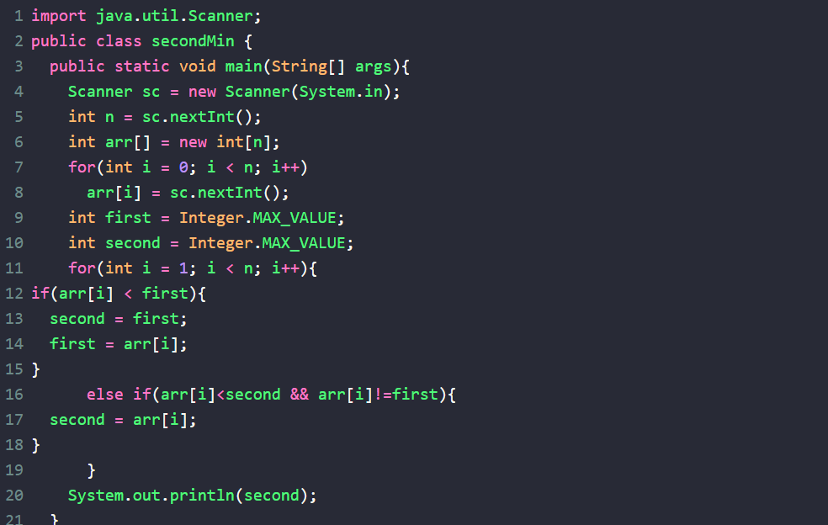
INPUT:
6
10 3 45 1 22 5
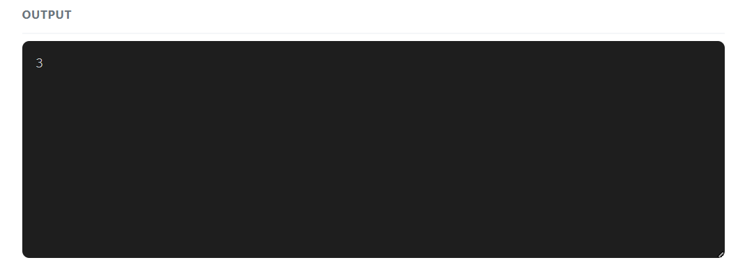
PROGRAM:30
TITLE:SORT-B
A JAVA PROGRAM TO IMPLEMENT BUBBLE SORT ON ARRAY OF INTEGERS USING LOOPS AND CONDITIONAL STATEMENTS
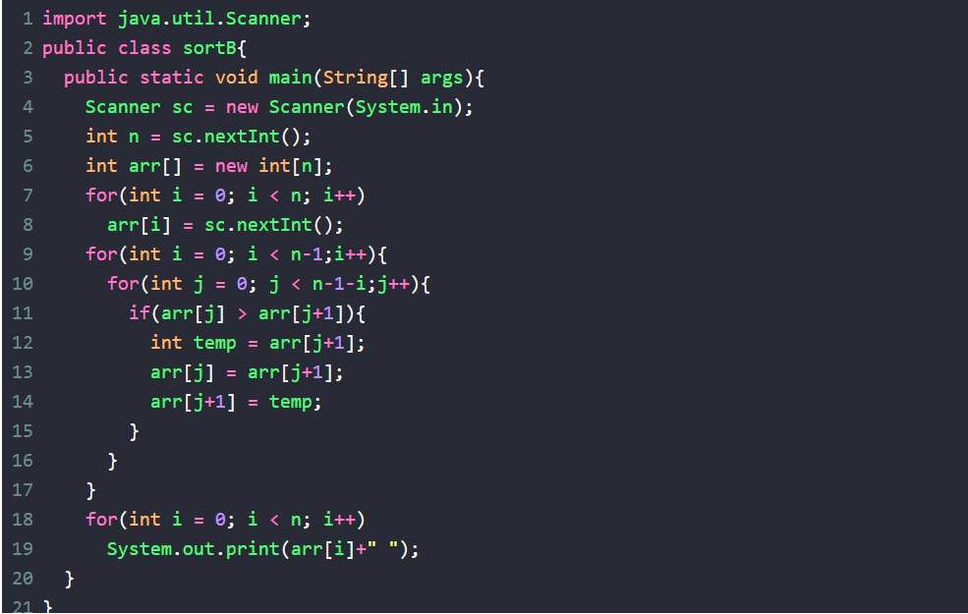
INPUT:
5
5 1 2 4 8
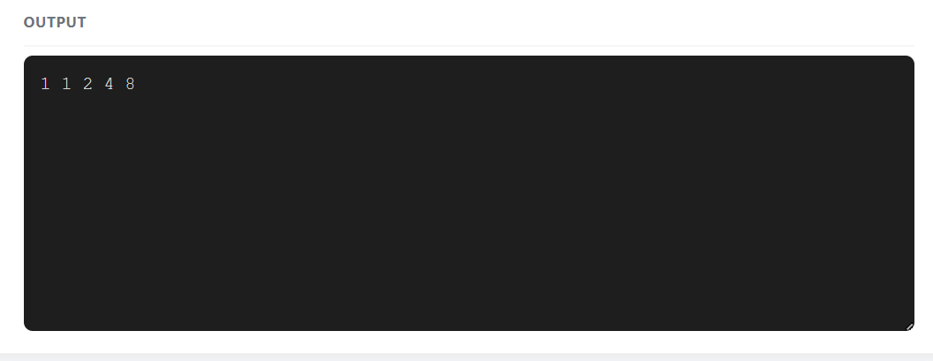
PROGRAM:31
TITLE:SORT-I
A JAVA PROGRAM TO IMPLEMENT INSERTION SORT ON AN ARRAY OF INTEGERS USING LOOPS AND CONDITIONAL STATEMENTS
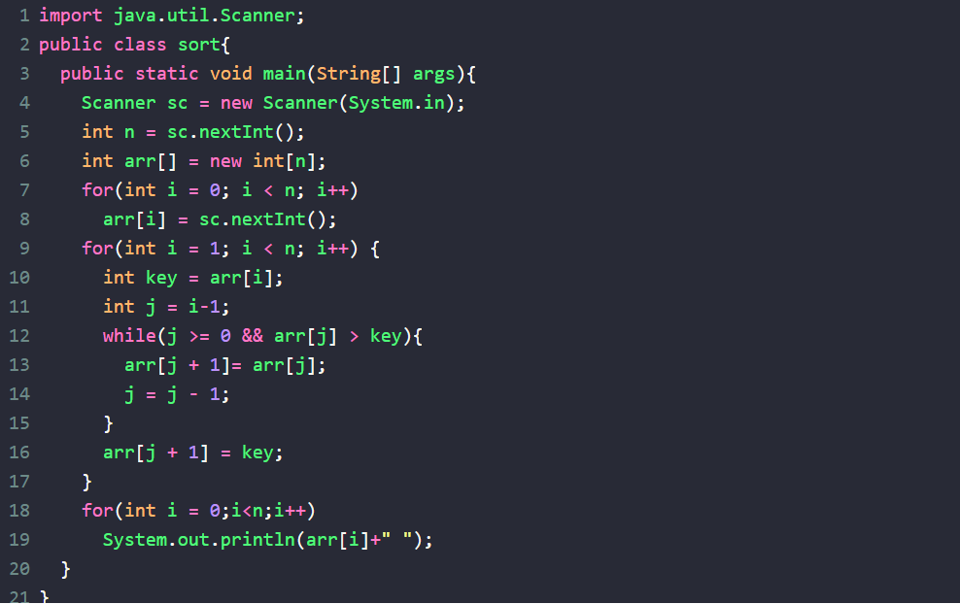
INPUT:
5
5 1 4 2 8
